Ideation

Fire Bird

* Some kind of flappy bird type game.
* Maybe some small changes, like visuals, but otherwise probably similar to flappy bird.
* Make the bird more rounded and yellow, I like the simple appearance of it.

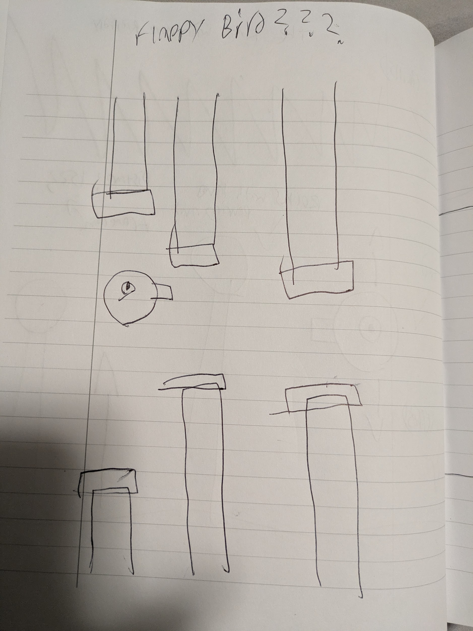

* Flappy bird just on it’s own isn’t quite

original enough, I want my own spin on it.

* Maybe having it some kind of narrow

hallway would be interesting, and you control

up or down instead of just a jump button.

* Cave as location? Spikes?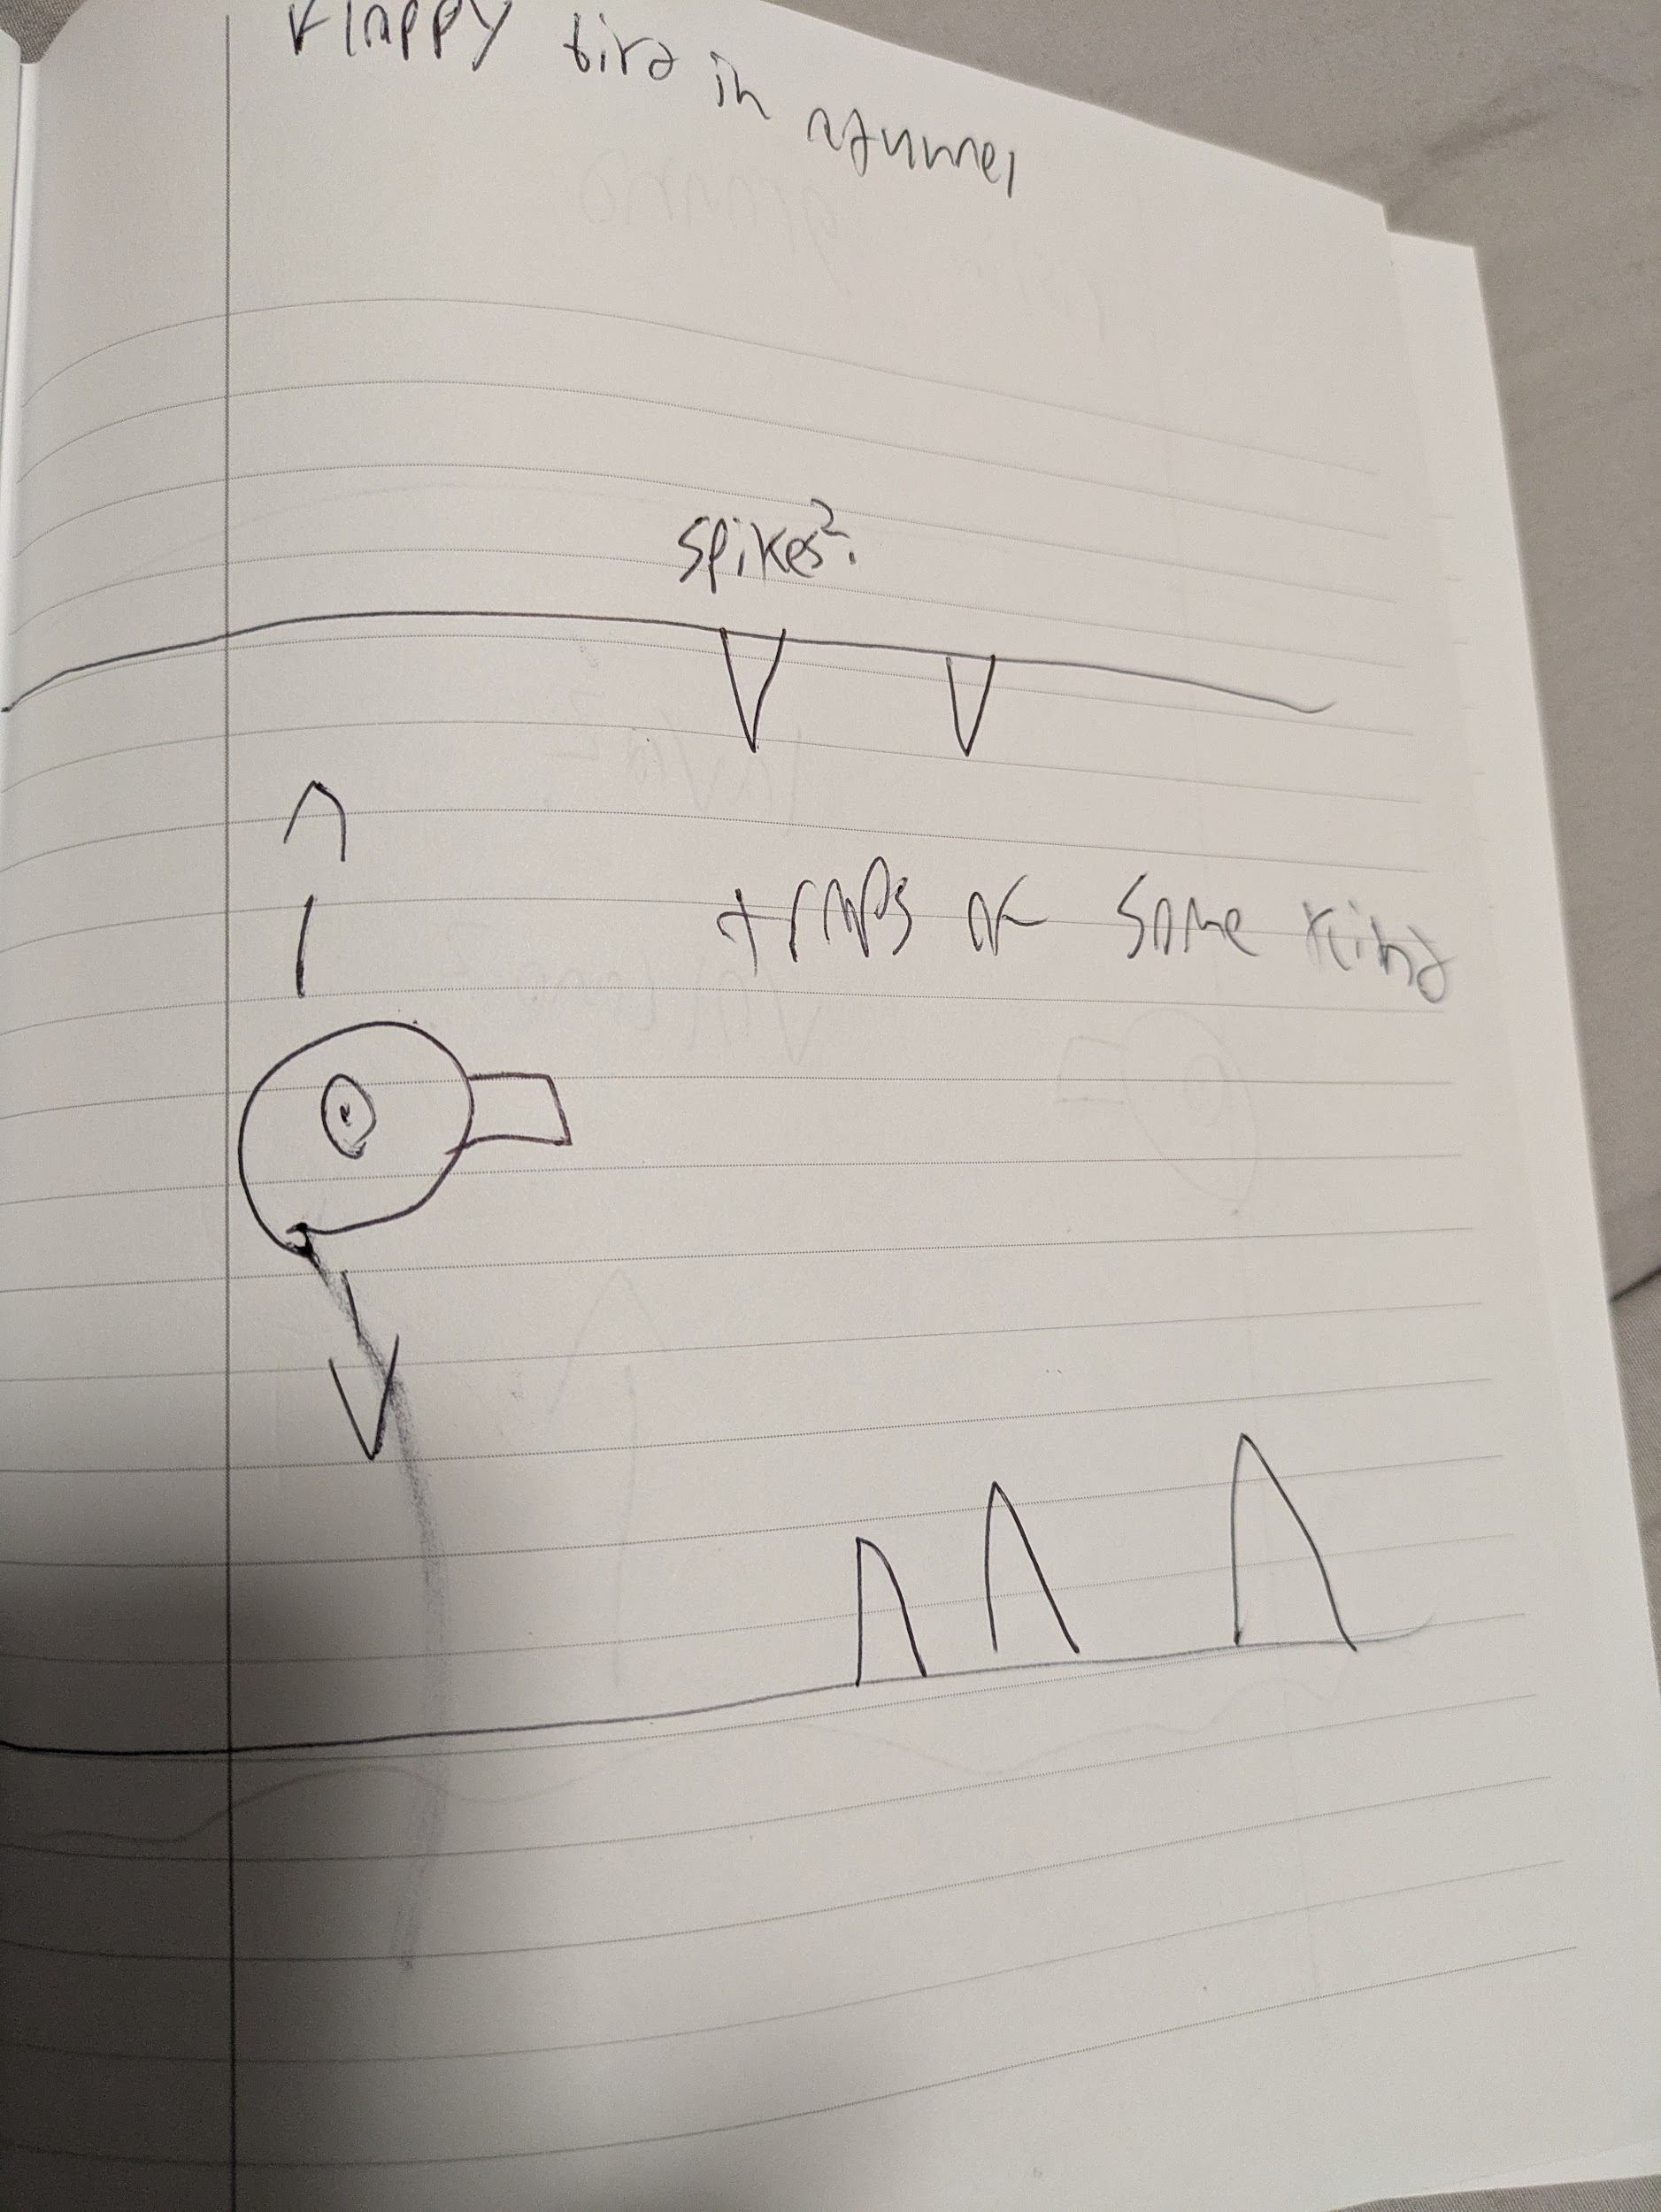
* The idea of a volcano sounds appealing.
* Lava could rise using frameCount and velocity, and then could kill the player?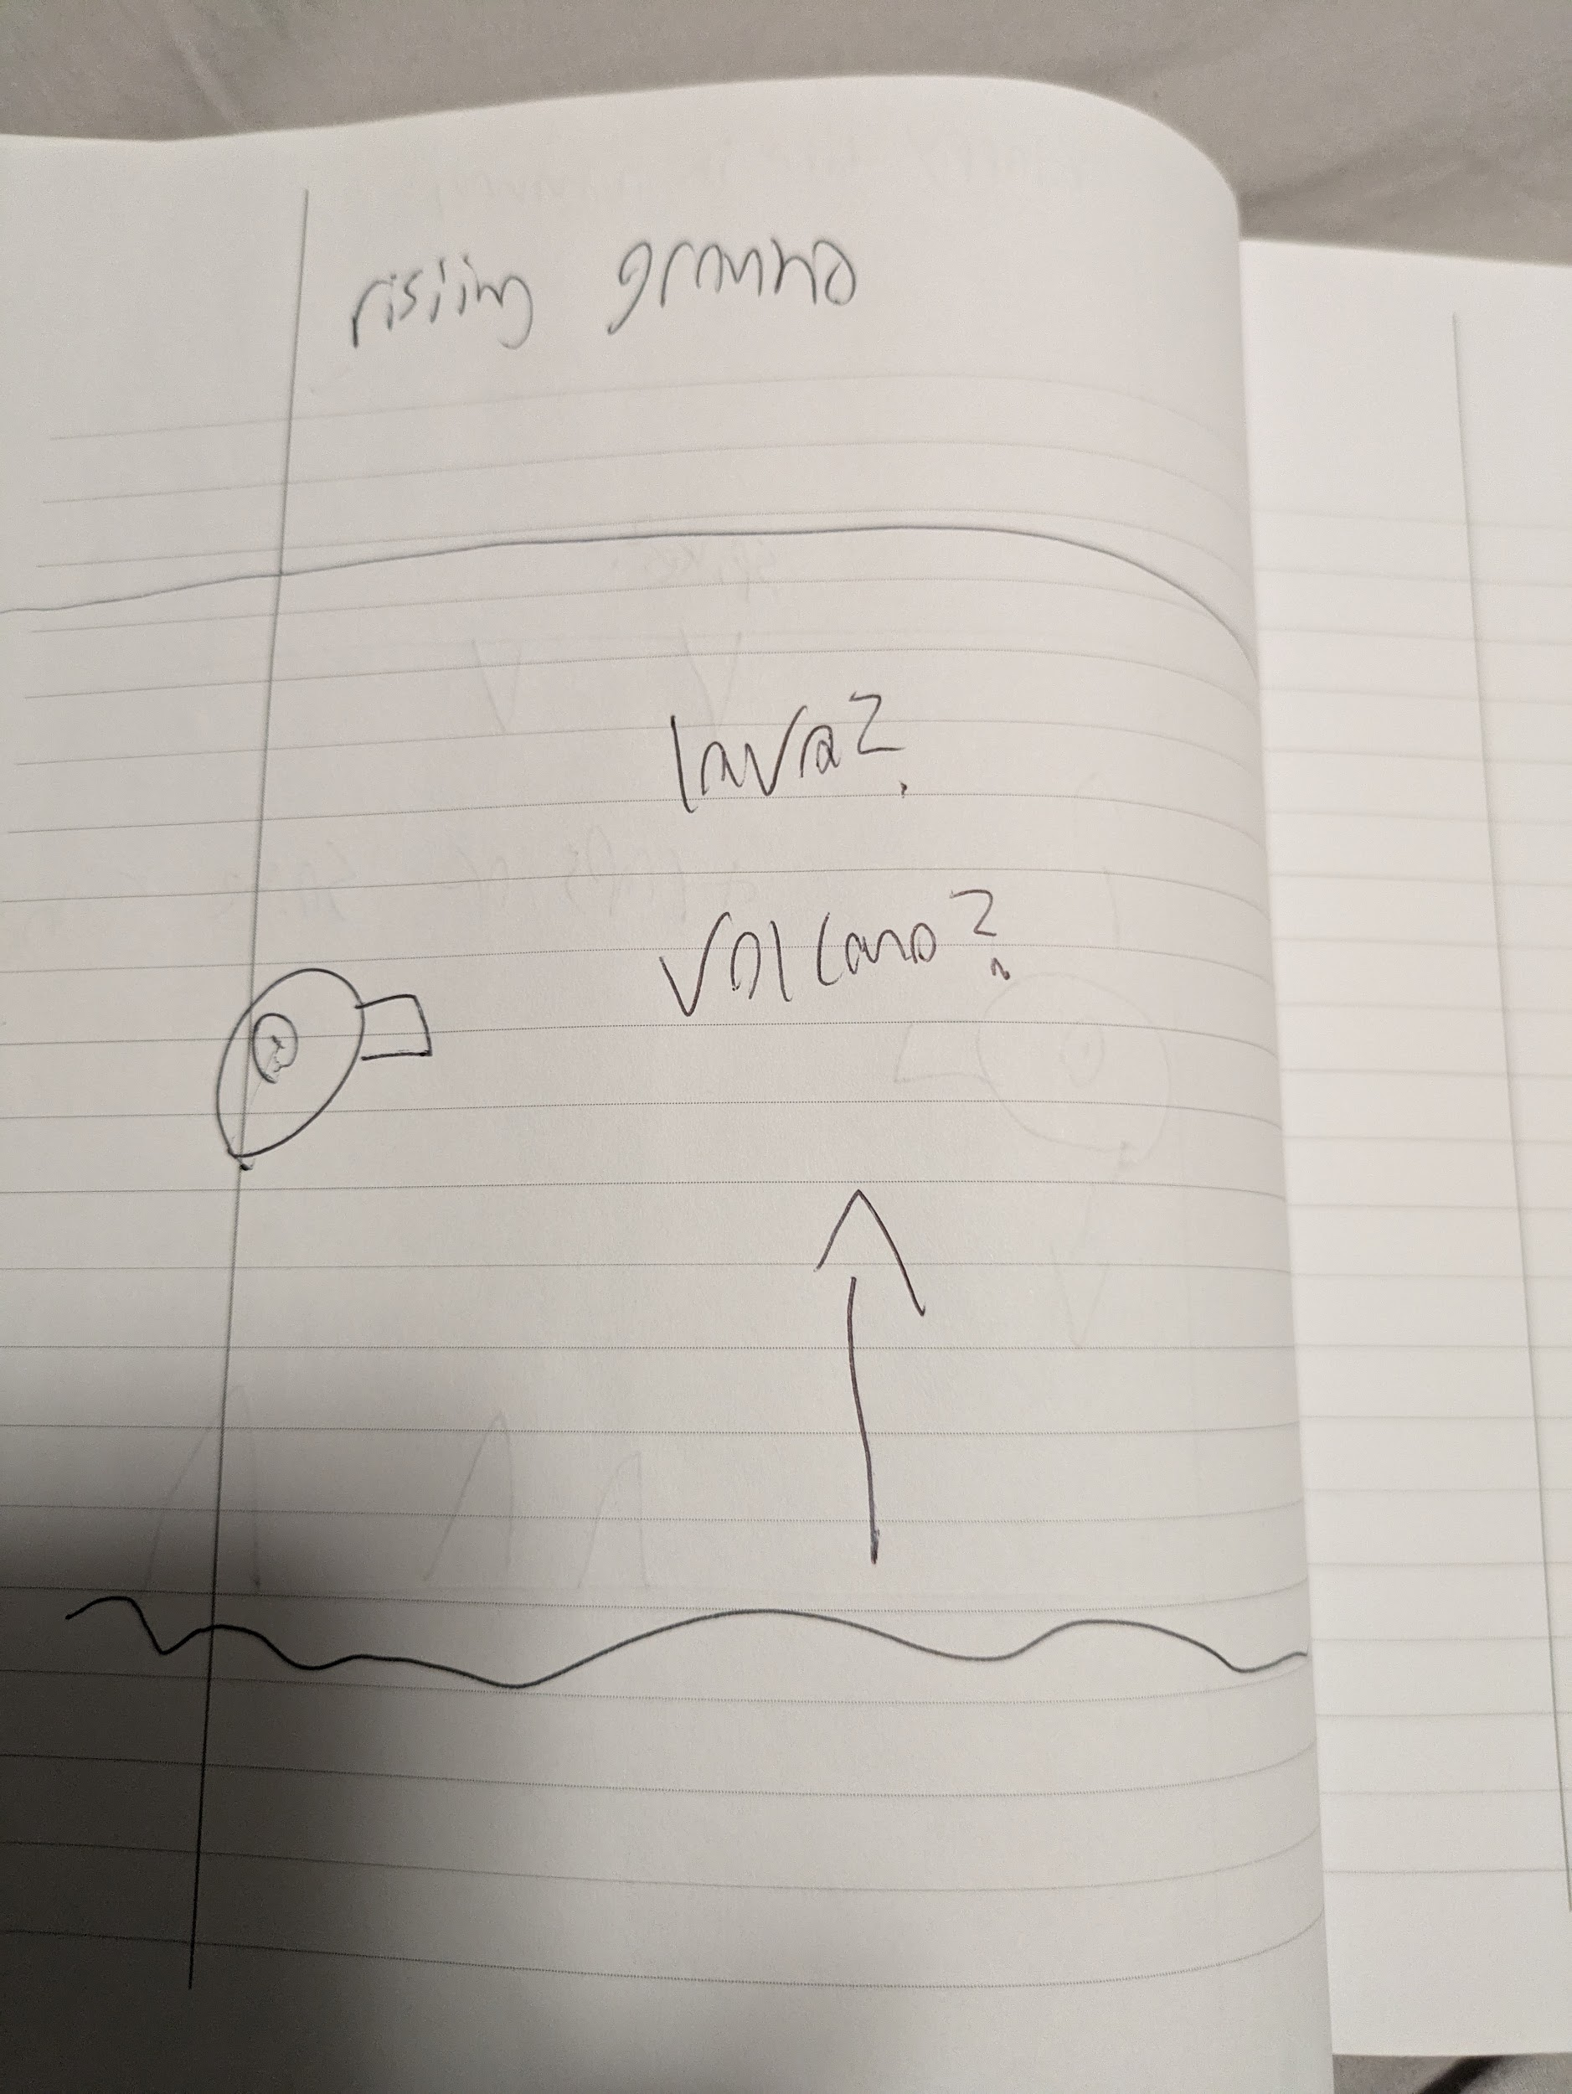
* Random fire at the top?